Reg No: 21MAI1003

MAT 6001 LAB 3

PROBLEM SHEET ON NORMAL TEST AND Z TEST

FACULTY: DR. G. HANNAH GRACE

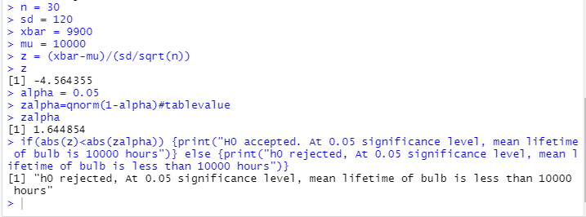

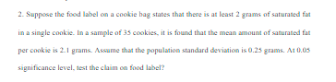

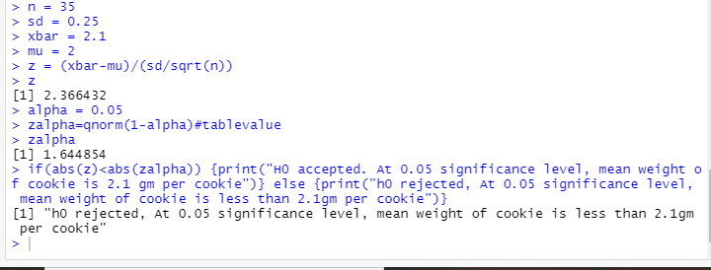

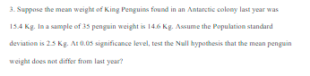

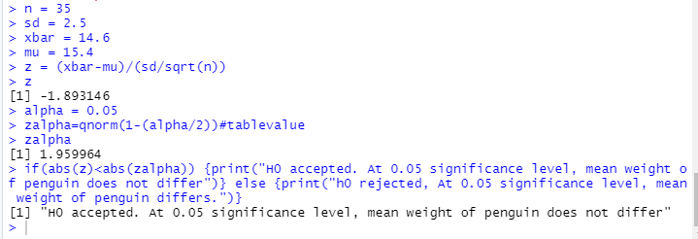

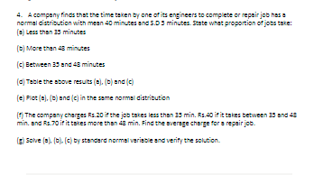

(a,b,c)

Code:

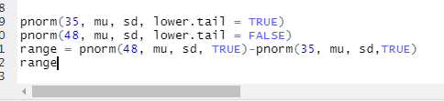

Output:

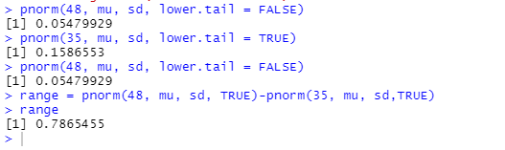

d)

TABLE:

Code:

df <- data.frame(range=c('<35','35-48','>48'),

partitions=c(p1,p3,p2))

Output:

e) Input:

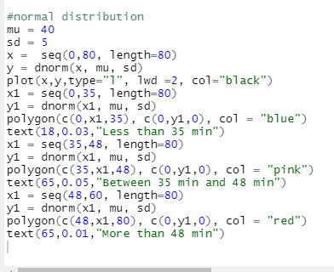

Output:

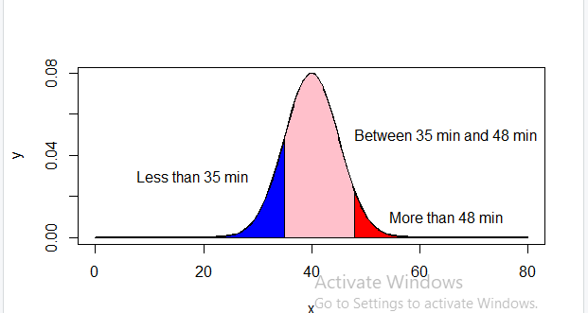

f) Code and Output:

g) Code and Output:

